PowerBI Case Study

Q1: Understanding category having highest Gross sales.

*Handmade-Jewellary is having highest Gross Sales*

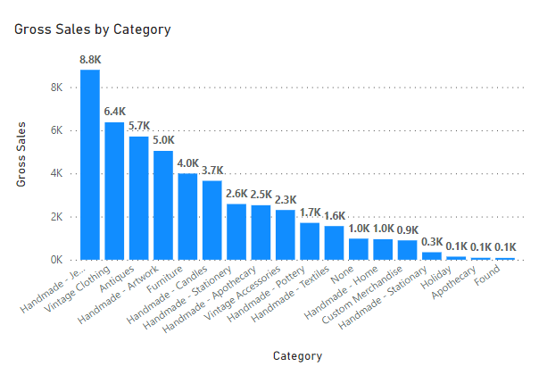

Q2: Cost associated with each category.

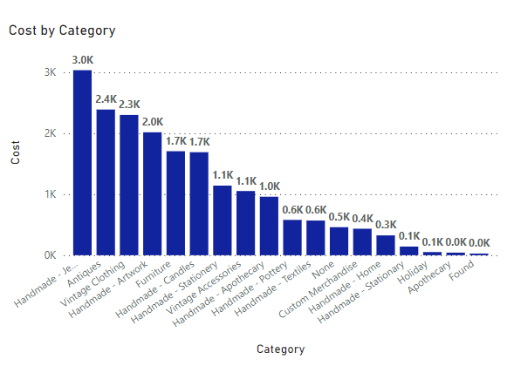

Q3: Profit margin on each category

Q4: Discounts associated with each category.

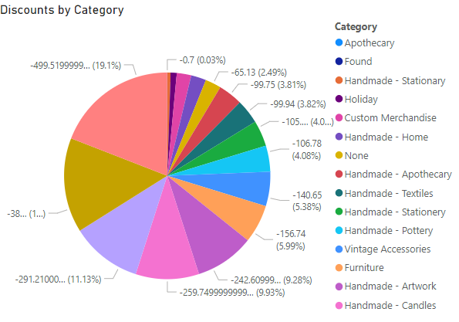

Q5: Visualization on SKU and Category.

Q6: Find Out Stock Keeping Unit (SKU) in Q3 Division.

Q7: Creating New Measures. Relationship between two quantity columns (Gross Sales and Cost)

*I Created Profit Measure*

Profit = SUM('Sample Retail Data'[Gross Sales]) - SUM('Sample Retail Data'[Cost])

Q8: Extract Average Sales, Profit and Discounts on All Categories.

Q9: Maps, Measure, Column

Column Creation:

Gross Profit = CALCULATE(SUM('Sample Retail Data'[Gross Sales]) - SUM('Sample Retail Data'[Cost]))

Measure Creation:

Profit = SUM('Sample Retail Data'[Gross Sales]) - SUM('Sample Retail Data'[Cost])

Relationship between two tables:

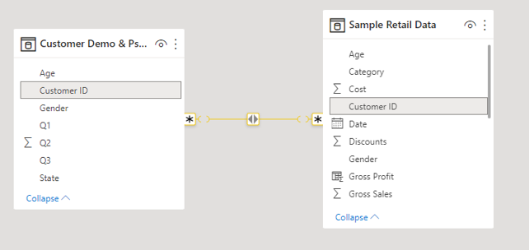

**Dashboard:**

